[SETTING UP APPLICATION ENVIRONMENT](https://careereducation.smartinternz.com/Student/guided_project_workspace/38367#collapse1)

**DOCKER INSTALLATION**

|  |  |
| --- | --- |
| Date | 1 Nov 2022 |
| Team ID | PNT2022TMID18036 |
| Project Name | Smart Fashion Recommender Application |
| Team Members: | Ramyadevi RS  Samyuktha V  Srija J  Subiksha R |

# 

**Step 1:** Go the official Docker website: [***https://docs.docker.com/desktop/install/windows-install/***](https://docs.docker.com/desktop/install/windows-install/)

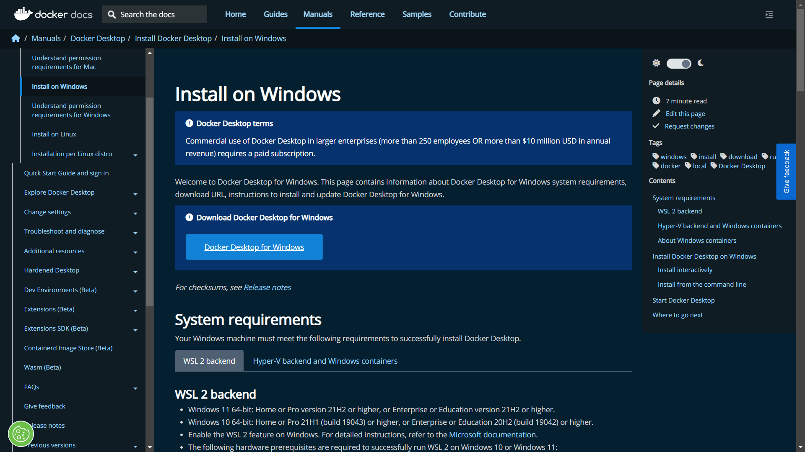

# Step 2: Click on Docker Desktop for Windows and download will start and it takes

few minutes to complete.

# Step 3: Go to downloads in browser (or) type ctrl + J, it will navigate to download page and double-click the particular docker file.

# Step 4: Now Installation is complete. This icon will be added in your desktop. Double-click the icon to start the docker app, you can register and login that app to access the credentials.

# Step 5: Docker will open up, if the left bottom side is shown in green color, docker will show the status of docker app working successfully.

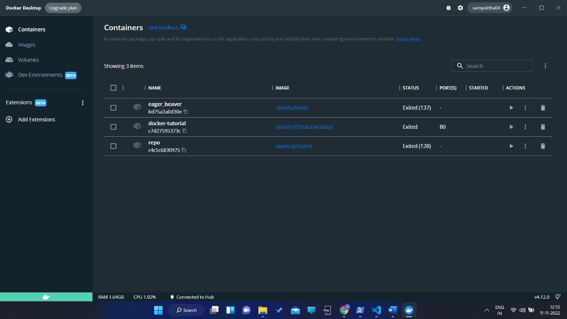

# Step 6: Finally, the docker is installed successfully.